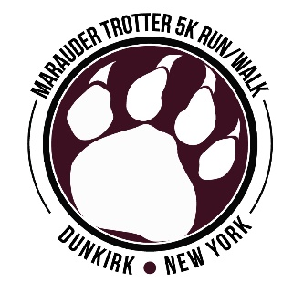
MARAUDER TROTTER 5K 2016 – HOMETOWN PRIDE
SPONSORSHIP, DONATION & VOLUNTEER OPPORTUNITIES

Dear Community Partners and Friends:
THANK YOU so much for your sponsorship and/or donation to last year’s Marauder Trotter 5K Run/Walk & Kids’ Run. With your support, we were able to raise $5,000 to support our DHS Class of 1989 Memorial Scholarship in honor of our deceased classmates – Paula Kuschel, Jennifer Styborski, Jody Wdowiasz, Mike Koch, Robert Pierce, James Kulpa, Susan Butts, Elizabeth Barnes, Tony Quiles, Susan Stoyle (Gorka), Scott Roesler, Todd Iskra and Joe Pieszak.

We cordially invite you to participate again as a sponsor, donor and/or volunteer of the 2nd Annual Marauder Trotter 5K Run/Walk & Kids’ Warrior Challenge on Saturday, July 2, 2016 starting at 9 a.m. along the new race route – the waterfront on beautiful Lake Erie at Wright Park.

Your sponsorship/donation helps to defray the cost of organizing the event. Funds received from sponsorships are used to purchase T-shirts for registered race participants, awards and complimentary drinks and snacks for each race participant. Any additional money from sponsorships will help go toward our fundraising goal of $5,000 this year.

With this in mind and our need to start preparation for this important fund raising event now, we are asking that you take some time to review this packet and let us know very soon if you can help us host another successful race. Please feel free to share this information with others too!

There are various levels of corporate/family sponsorship for the Marauder Trotter listed below:

Platinum Level Sponsor ‐‐ $1,000 (only one available)
• Listed as top sponsor on web site with logo and link
• Prominent display of logo on all race T-shirts, event poster and event banner
• Opportunity to speak at opening of race
• Name printed on swag bag and promotional materials in race packet
• Special PA announcements mentioning sponsor name during and after the race
• Name on finish line break tape
• 4 complimentary race entries

NEW this year! Kids’ Warrior Challenge Sponsor ‐‐ $500 (only one available)
• Listed as sole Kids’ Warrior Challenge sponsor on web site with link
• Logo/name on race T-shirt, event poster and event banner
• Promotional materials in race packet
• Special PA announcements mentioning sponsor name during and after the race
• 3 complimentary race entries

Gold Level Sponsor ‐‐ $500 Marauder Trotter 2016 Sponsorship, page 2
• Listed as sponsor on web site with link
• Logo/name on race T-shirt, event poster and banner
• Promotional materials in race packet
• Special PA announcements mentioning sponsor name during and after the race
• 3 complimentary race entries

Silver Level Sponsor ‐‐ $250
• Listed as sponsor on web site with link
• Logo/name on race T-shirt and event poster
• Promotional materials in race packet
• 2 complimentary race entries

Bronze Level Sponsor ‐‐ $100
• Listed as sponsor on web site with link
• Promotional materials in race packet

Finish Line Sponsor ‐‐ $100
• Name prominently displayed below the finish line clock

Swag Bag Sponsor ‐‐ Responsible for providing printed bag (plastic or material) for all race participants which includes adding promotional item
ΣΙΜΠΛΨ ΠΕΡΦΕΧΤ ΠΡΟΜΟΤΙΟΝΣ, Δυνκιρκ (2016 Σπονσορ – Τηανκ Ψου!)

Mile Marker Sponsor ‐‐ $75 each
• Name will appear on one mile marker sign, which will be prominently displayed at
the 1 mile mark, 2 mile mark or 3 mile mark.

Water Station Sponsor‐‐ $75
• Name will appear on a prominently located sign at water station

Monetary Donation
• Can be made on-line at https://runsignup.com/Race/NY/Dunkirk/MarauderTrotter5KRunWalk
or mailed checks payable to DHS Class of 1989 and mailed to:
Jennifer Ellman, 3705 New Road, Dunkirk, NY 14048

Food/Drink Donation (bottled water, sandwiches, granola bars, bananas, apples, etc)

Basket Auction Donation (basket, gift certificate, etc…)

Event Volunteer (registration, route personnel, kids’ run, basket auction, bounce house attendant)
• Αλλ volunteers will be contacted with assigned time and duty before event

Marauder Trotter 2016 Sponsorship, page 3

Thank you in advance your consideration of becoming a race sponsor, donor and/or volunteer. Attached you will find a sponsorship/donation/volunteer form that can be completed and submitted by mail or
e-mail. Please feel free to contact us if you have any additional questions.

Sincerely,

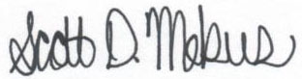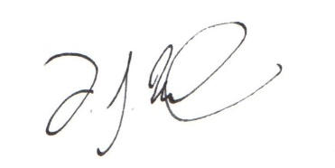
Scott Mekus, Event Manager (716) 720-0564 DJ Wilson, Race Director (716) 785-1537
Marauder Trotter Contact Information:
Website: www.maraudertrotter.weebly.com
E-mail: maraudertrotter@yahoo.com
Facebook: Marauder Trotter 5K Run/Walk
Registration: https://runsignup.com/Race/NY/Dunkirk/MarauderTrotter5KRunWalk
Address: Jennifer Ellman, 3705 New Road, Dunkirk, NY 14048

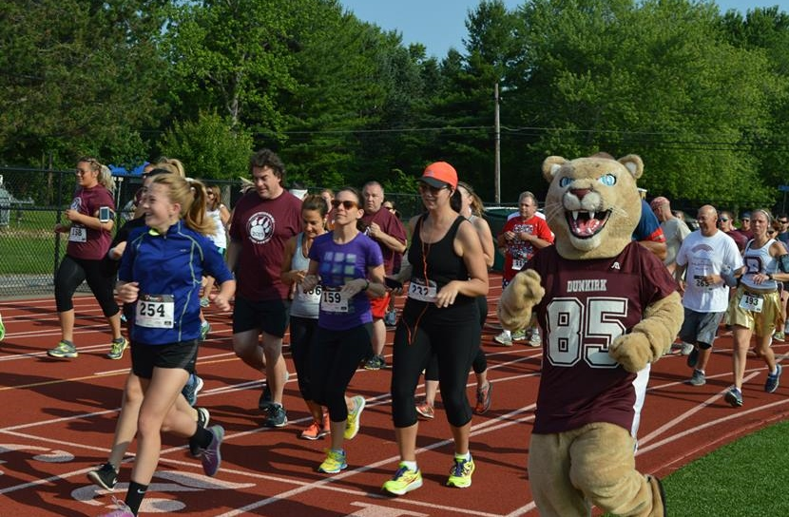

Marauder Trotter 5K Run/Walk & Kids’ Warrior Challenge 2016
Sponsorship/Donation/Volunteer Form
July 2, 2016 at Wright Park, Dunkirk, NY

Organization/Family Name:____________________________________________________________________

Address: ______________________________________________________________________________________

City: ___________________________________________________________ State: _________ Zip: ____________

Contact person: ________________________________________________________________________________

Contact email: _______________________________________________ Phone number: _____________________

Website address: _________________________________________________________________

Sponsorship Level (please circle one)

Platinum Kids’ Warrior Gold Silver Bronze Finish Line Swag Bag Mile Marker Water Station
$1,000 $500 $500 $250 $100 $100 (Simply Perfect Promotions) $75 $75

We plan to send or drop off materials/giveaways for the participant bags (at least 250 items): Yes No
If yes, what item would you like us to include: ____________________________

Sponsors can choose to have company/family name listed or submit a logo. Please write your name exactly how
you’d like it to appear on web site, signage, etc.: _______________________________________________

Artwork and logos should be submitted to maraudertrotter@yahoo.com as follows:
o Logos for T-shirts will be printed only in one‐color and should be submitted as hi‐res (300 dpi) JPEG
or EPS files. Most Photoshop and Illustrator files can also be accepted.
o Logos for signage should be submitted as hi‐res (300 dpi) JPEG or EPS files.
o Logos for web site should be submitted as 72 dpi JPEG or PNG files.
Checks payable to DHS Class of 1989 and mailed by June 1 to: Jennifer Ellman, 3705 New Road, Dunkirk, NY 14048
Monetary Donation
• Yes – I can donate $_______
Donations can be made on-line at https://runsignup.com/Race/NY/Dunkirk/MarauderTrotter5KRunWalk
or mailed checks payable to DHS Class of 1989 and mailed to Jennifer Ellman at above address.

Food/Drink Donation (bottled water, granola bars, bananas, apples, etc…)
• Yes – I can help here! I plan to donate ____________________________________________________________

Basket Auction Donation (basket, gift certificate, product, etc…)
• Yes – I can help here! I plan to donate ____________________________________________________________

Swag Bag Item (at least 250 items) - gift certificate, coupons, flyers, promotional items, etc..
• Yes – I can help here! I plan to donate ____________________________________________________________

Event Volunteer (registration, finish line, route personnel, kids’ warrior challenge, basket auction, bounce house aide)
• Yes – I can help here! I would prefer the following volunteer duty _____________________________________
Tax Receipt
• Yes – I would like a receipt for tax purposes emailed or sent to me

